Instructions for use of Song Show

Requirements
Song Show can run on any Windows based computer or laptop.
A desktop computer needs to have two graphics outputs and a laptop needs to have an output in addition to it’s built in screen. With a projector connected, the computer needs to be put into extended desktop mode (if this is not already set try pressing Windows-P and choosing Extended desktop from the choices that appear).
Songs are held in text files that are coded up for Song Show. Song Show can be connected to a web site hosting a list of songs and download them from there when the computer is connected to the internet.

Configuring Song Show
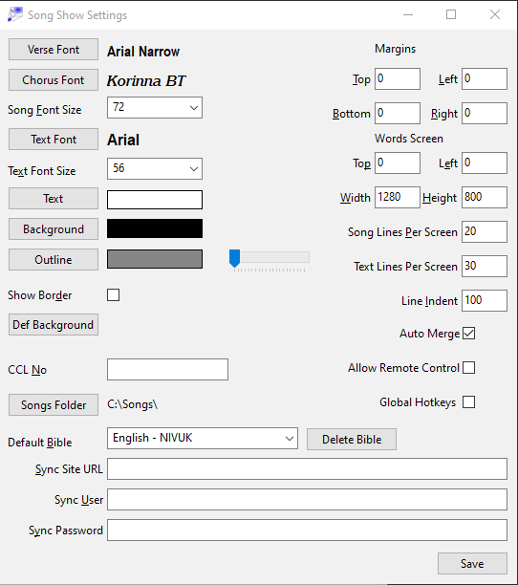
The first time Song Show is used, it’s settings should be adjusted to match the requirements for where it’s being used and how the computer is configured. The settings are accessed by choosing Setup on the Tools menu.
The settings are as follows:
- Verse Font – this font will be used to display verse text and all other text except choruses
- Chorus Font – this font will be used to display choruses
- Song Font Size – when displaying songs this is the text size that will be used
- Text Font – Song Show can also be used to display text other than songs (e.g. Scripture). In this instance this is the font that will be used
- Text Font Size – This is the text size that will be used for non-song text and scripture.
- Text / Background / Outline – these are three colour choosers to pick the text colour, the background colour and the outline colour. Next to the outline chooser is a slider which sets the width of the outline. Outline is only needed if Song Show output is being merged with video or shown over a background image. If that is not the case, it is advised to keep the slider fully to the left.
- Show Border – this displays a 1 pixel wide border around the words window when it is shown. Typically this is used to help adjust projector output to get the projector to correctly identify the edges of the image. Often needed when setting up a VGA connected projector. Usually once the projector has been adjusted this can be switched off again.
- Def Background – sets an image that will be the default background for all screens. If using a background image it is advisable to use and outline.
- CCL No – this should be filled with the CCL license number that covers the use of song words for the area the computer is being set up for.
- Songs Folder – choose the folder on the computer where the song files are going to be stored.
- Default Bible – multiple Bibles can be loaded and this sets which one will be used by default when displaying scripture.
- Sync Site URL – Song Show can synchronise songs from a web site hosting a database of songs. The address to access that database should be entered here.
- Sync User / Sync Password – to just download songs from the database no user name or password are required. However, authorised users can amend songs on Song Show and have those changes synchronised back to the database. This is where the credentials should be entered for that.
- Margins (Top / Left / Bottom / Right) – these are the gaps that should be left between the edge of the words screen and where the words are displayed. For normal use they can often all be 0, but can be adjusted if not all of the projector output is visible.
- Words Screen (Top / Left / Width / Height) – by default Song Show creates it’s words screen on the primary screen of the computer. However, often that is the “local” screen (particularly with laptops). These settings allow the words screen to be moved and sized correctly to match the real set up. If the projector is a different resolution to the primary screen, enter the projector resolution in the width and height settings. Use the Top and Left settings to move where the words screen is displayed. E.g. if the primary screen is 1280 pixels wide and the projector screen is laid out to the right of the primary, set Left to 1280 (the left edge is being moved by 1280 pixels). Some trial and error can be needed to get these settings correct. It can be useful to set the background colour to a bright colour to see where the words screen is being displayed.
- Song Lines Per Screen – this is a maximum number of lines that will be displayed per page of a song.
- Text Lines Per Screen – this is the maximum number of lines of text (e.g. Scripture) that will be displayed on one page.
- Line Indent – when a line of a song wraps, any wrapped part of the line will be indented by this much
- Auto Merge – when this option is selected, if song verses are short and the number of lines per screen allows, more than one verse will be displayed on a page.
- Allow Remote Control – enables a basic HTTP interface for controlling some aspects of Song Show. There are two uses of this. Accessible at http://<host IP>:8001/ is a user interface which allows operation of Song Show from another computer. In addition, there are HTTP URLs which can be called by a plugin for Egalto Streamdeck to perform some Song Show functions. The first time Song Show is started after this option is enabled, Windows will ask whether you want to allow access through the firewall.

Components of the Control Window
The Song Show Control Window is where songs are searched for, play lists are built and the display of songs is controlled.
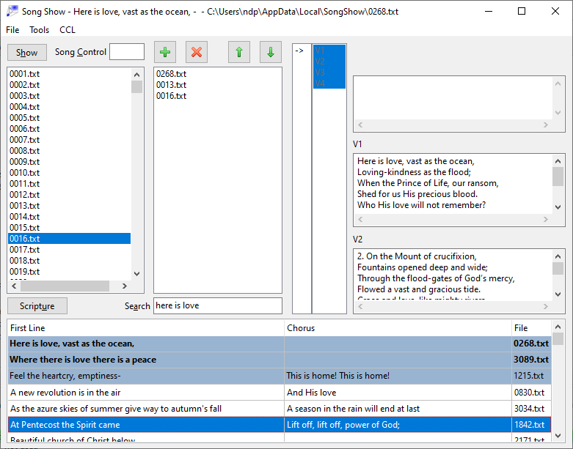
Song file list
Play List
Play List Controls
Previous verse
Current verse
Next verse
Song structure
Search results
Search results
Search text
- Show – this button displays the current song on the projector. It changes to say “Hide” when the song is visible and will then take the song off the screen.
- Song Control – this is the key control when showing songs. Click into this box to allow the keyboard functions for showing and moving around a song to work
- Songfile list – lists all the song files that this copy of Song Show has read.
- Play List Controls – these buttons are used to manipulate which songs are in the current play list
- Play List – the current play list of songs
- Song Structure – shows the verses of the currently loaded song. The arrow in the left column shows the current verse. If the current song is set up to have a loop, that can be seen in the colouring of the items in the right hand column.
- Previous verse – as you move through the song, the verse before the current one on screen is shown here
- Current verse – text of the current verse is shown here
- Next verse – text of the next verse is shown here.
- Scripture – if a Bible is loaded into Song Show’s database, this button will show and allows quick display of sections of the Bible.
- Search String – use this box to enter words to search for in the Song Show database.
- Search Results – the results of a search are displayed here.

In addition the menu at the top of the control window has the following options:

- File
  - New Song – enter a brand new song using a simple editor
  - New Source – create a new song or other set of screens using Song Show markup.
  - Edit Song – use a simple editor to edit the screens of the current song
  - Edit Source – edit the source of the current song – for those familiar with Song Show markup.
  - Publish – if Song Show is configured to sync with a web site and the current song is a local one rather than one from the site, this will, for site users with appropriate permissions, publish the song to the site.
  - Load Playlist – load a play list from a previously saved file
  - Save Playlist – save a play list to a file. Play lists are not automatically saved when Song Show is closed, so if a play list needs to be kept between sessions then save it and load it in the new session.
  - Export Index – exports a list of the songs in this copy of Song Show in CSV format. The export includes the file name, the first line of the first verse and the first line of the chorus.
  - Image Export – once a song is loaded, the screens that would be displayed as the song is shown can be exported as a series of PNG images. Particularly useful if Song Show is bing used to prepare scriptures in multiple languages which can then be embedded within a presentation.
  - Load Bible – basic scripture display is possible in Song Show and this option can be used to load Bible files in XML format into Song Show’s database. Bibles can be downloaded from http://www.ph4.org/b4_mobi.php?q=zefania . Loading Bibles will take some time.
  - Exit – close Song Show.
- Tools
  - Setup – the access to the Settings window already described.
  - Sync Songs – once the Sync Site URL is configured, this option will show and, when connected to the internet, will allow download of up to date songs from the configured songs database.
  - Scan Songs – if the files in the songs folder have been changed outside Song Show (e.g. new files copied in there or files deleted) then choose this option to get the Song Show database updated with the current files available.
- CCL
  - Start Recording – if the event that songs are being shown for is covered by the CCL licensing arrangement, use this option to indicate that the event has started and Song Show will record the use of songs that have CCL markers. A prompt appears asking for the name of the event – what is entered here will be available in the reporting.
  - Stop Recording – use this option to stop recording usage of songs for CCL purposes. Song Show automatically stops recording usage when it is closed, so this option is only needed if the event has finished and more songs are going to be loaded and shown for test purposes.
  - Export Report – export a CSV report of the song usage that has been captured for CCL purposes. Choosing this option will present a dialog box asking for the data range for the report and whether a Summary or Detail report is needed. The Summary report lists each song that has been recorded and the number of times it was used. The Detail report lists every use of a song including the date and the event name as entered when Start Recording was chosen.
The song file list has a right click menu with the following options:
- Edit Song – edit the selected song
- Edit Source – edit the source of the selected item
- Delete – delete the selected item
- Publish – publish the selected song to the synced web site
Note – this menu operates on the selected item in the list – i.e. the item which is highlighted – not the one at the point where you press the right mouse button.

Basic Song Projection
Songs can be loaded from the song file list, search results or play list. For all three, simply double click on the required song to load it.
To search for a song, enter words from the song in the search string box and press [Enter]. The results will be displayed below.
Song Show looks for words wherever they appear in songs and removes all punctuation before searching. If the words searched for form a phrase rather than just being words that exist in a song, then the search results have a coloured background (as per the first three in the sample picture). If the phrase exists in the first line of the first verse or the first line of the chorus then the text in the search results is bold (as per the first two in the sample picture).
With a song loaded, and the cursor in the Song Control box (this will happen automatically after double clicking on a song), the following keys are the normal way to control what is on screen:
[Insert] or [F5] – show the song
[Delete] or [Escape] – remove the song from the screen
[Page Down] – move to the next screen
[Page Up] – move to the previous screen
[Home] – go to the first screen
[End] – if the song has a loop, then the first screen after the loop, otherwise if it has a page called END then that one otherwise the last screen.
In addition, typing the name of a page of the song and pressing [Enter] will go directly to that page. E.g. typing v3[Enter] will go directly to the page labelled v3. Typing the name of a page that occurs more than once in the play order will go to the first instance of that page.
Typing a short phrase from the current song and pressing [Enter] will move to the first item in the song that contains that phrase on one line.

Using Play Lists
A list of songs can be collected together into a play list. This allows songs to be found before an event and built as a list rather than searching as they are required.
Songs are added to the play list by either clicking once on them in the file selector and pressing [Insert], or finding them using the search, clicking once on them and pressing [Insert]. Additionally, songs can be added to the play list by dragging from either the file selector or search results. Alternatively the green + button adds the current song to the play list.
The play list can be re-sequenced using the arrow buttons above the list or dragging items up and down within the list, and songs can be removed using the red X button.
Play lists can be saved using the File → Save Playlist menu option and then re-loaded using the File → Load Playlist menu option.
To display the songs in a play list, double click on the first song in the list to load it as the current song. When the next song in the list is needed use [Ctrl]-[Page Down] to load the next song in the play list. [Ctrl]-[Page Up] will load the previous song in a play list.

Song Editor
For editing songs, Song Show has an editor which has presets for all the normal sections used in songs. This editor is accessed by using either File → New Song, for creating new songs, or File → Edit Song, for editing the currently loaded song.
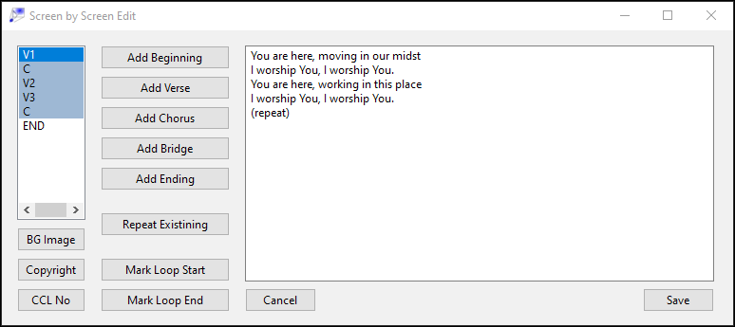
Song structure
Verse Editor
The Song structure box on the left will show the sequence of screens that make up the song – which will be blank initially for a new song.
The Add buttons all add a new screen of the relevant type. If a particular screen is repeated within a song then the Repeat Existing button will present a list of existing screens to choose from.
All new screens are added at the end of the list; screens can be re-sequenced by clicking on the screen to move and then right clicking and choosing Move Up or Move Down.
If a screen needs to be removed from a song, click on it in the Song structure box and then right click and choose Delete.
Mark Loop Start and Mark Loop End will cause the currently selected screen to be either the start or end of the default loop which happens when projecting the song. The three buttons under the Song structure box add the special sections to the song – a background image, the copyright details and a CCL song number.
Clicking Save when creating a new song will ask for a file name for the song. Saving an existing song will simply replace it and if it is the current song that is loaded, then it will be reloaded, returning to the same place in the song if it still exists.

Coding format for Song Show
Those familiar with HTML will see where the inspiration for Song Show format came from. Songs are stored as plain text documents with some mark up added to show which part is which verse. This is the format which can be edited when New Source or Edit Source is chosen from the File menu.
Here is an example:
[V1,C,V2,C],END
<V1>
Line 1
Line 2
Line 3
</V>
<C>
A little chorus
With lots of meaning
</C>
<V2>
2. Line 1
Line 2
Line 3
</V>
<END>
Ending:
Special lines for the end
</END>
<COPY>
Copyright holder @ 2018
</COPY>
<CCL>
</CCL>
The first line is what’s called the play order. It says what order each of the components of the song should be used and it also can be used to mark a default loop. This means that, for example, if there is a chorus used more than once, it only needs to be included once and can simply be included in the play order several times. The play order consists of the names of the components of the song separated by commas. [ and ] are added to show where the default loop begins and ends. If there is no loop then they are not needed.
[V1,C,V2,C],END
says the sequence is V1 followed by C followed by V2 followed by C then loop back to the beginning. There is then an END outside the loop.
If no play order is entered then the song will be shown in the sequence that the verses appear in the rest of the file. This is often useful for hymns which simply follow a list of verses and don’t have a repeated chorus.
Each verse or chorus starts with a marker like <V1> on a line by itself and ends with a marker like </V> on it’s own line.
A few markers have special meaning, noticeably any that start with a C (e.g. <C> or <C1> etc.) will be displayed in the chorus font and in italic, <COPY> is the copyright information and is displayed on the bottom right of the last screen, <CCL> doesn’t need any information inside it, but if it is there then the CCL number entered in the setup screen will be displayed after the copyright.
Any songs with the CCL marker in the mark up which are shown for more than 1 minute will be added to a CCL log file which can be used to help with CCL reporting. A warning is shown if CCL recording is active and a song file is opened that does not have CCL markers.
In addition <BGIMG> can be used to define a background image for a song, which takes precedence over the default image set up in the Settings screen. This can either be a full path to the image, or a relative path to the songs folder.
There are three other markup tricks that can be used:
Lines wrapped in curly brackets { and } change from normal to italic (if they would have been normal by default) and from italic to normal in the case of chorus lines. This is useful for marking things like (repeat) sections which don’t apply to the whole of a verse.
If the | character is put at the end of a line, then that is an indicator to Song Show that the verse could be broken at that point if it is too long to go onto one screen. This allows verses to be kept intact in the text, but allows for different configurations to have the verses broken as needed while mainlining a flow in the way the song is presented.
If the | character is put at the beginning of a line then, if the line has to wrap, it won’t attract any indent on the wrapped part of the line. This allows Song Show to be used for displaying arbitrary text.

Displaying Scripture
If a Bible file is loaded into Song Show’s database then special markup allows scriptures to be displayed
<SCRIP1>
Mark|1:1-5
</SCRIP>
Will display Mark, chapter 1, verses 1-5. The markup sections must begin SCRIP and then the contents of the section is <book name>|<chapter>:<verse from>-<verse to>
In addition sections with names beginning TEXT can be used for any arbitrary text displayed in the text font size.
Rather than pre-preparing a set of scriptures to display, individual sections of scripture can be displayed using the Scripture button.
Clicking this will display a window which allows you to choose a book, chapter and a range of verses. In addition, you can build a list of scriptures to display in this window, plus there are additional controls for displaying additional Bibles simultaneously on the screen.
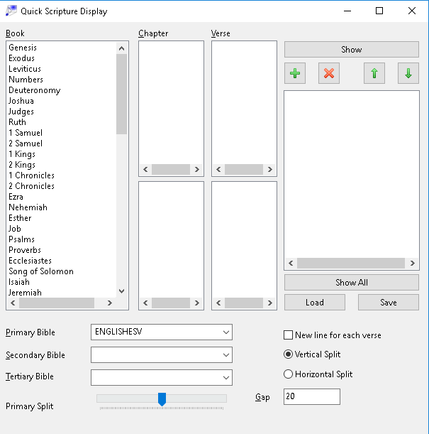
Click in turn on the book and chapter that you want. Then click on the first verse and either shift-click or ctrl-click on the last verse. Then click the Show button to display the scripture on the screen.
To build a list of scriptures to display, use the green + button to add the selected scripture to the list. The other buttons above the list of scriptures work in the same manner as the buttons above the song play list for removing entries from the list and re-sequencing.
Below the Book / Chapter / Verse selectors, are a series of settings for Bible display. The Secondary Bible and Tertiary Bible options allow second and third Bibles to be chosen to be shown on the screen in parallel with the primary one.
If a secondary Bible is chosen, but no tertiary then the split on the screen can be either vertical or horizontal and the Primary Split control determines how much of the screen is taken up by the primary Bible – this can be useful if one translation is naturally longer than another.
If a tertiary Bible is chosen then the split is always vertical and ⅓ screen used by each Bible.
The New line for each verse option forces each verse to be displayed on a new line on the screen. If this is not selected, then verses are joined together to form a continuous paragraph.
Gap sets the amount of space that should be allowed between the multiple Bibles in pixels.

